## Week 1 | Assignment 1 | Git and IntelliJ | By: Sanya Dureja

**Q1.** What is the use of the git add command?

**Ans1.**

The git add command is used to stage changes in your files before committing them. It tells Git to include the updates in the next commit.

**Q2.** Write the command to create a branch “feature-group”.

**Ans 2.**

The command to create a branch “feature-group” in the Git repository is as follows:  
**git branch feature-group**

**Q3**. What is a pull request? Write the steps involved in creating a pull request.

**Ans 3.**

A pull request is a way to propose changes you've made in a branch to be merged into another branch (usually main) on GitHub.

**Steps to create a PR are as follows:**

Push your branch → Go to GitHub → Click “Compare & Pull Request” → Add title and description → Click “Create Pull Request”.

**Q4.** How do you add collaborators?

**Ans 4.**

* Go to your repository on GitHub → Click on Settings → Collaborators → Add GitHub usernames.
* Collaborators will get an invite and can edit your repo once they accept it.

**Q5.** What is the command used to commit our changes in github repo?

**Ans 5.**

The command used to commit our changes in github repo is as follows:

**git commit -m "your commit message"**

**Q6.** Create a GitHub account and repository to save all your assignment tasks. Example repository name: rg-assignments

**Ans 6.**

Sign up on GitHub, then click New Repository and name it rg-assignments.

You can now push your assignment files to this repository from your local machine.

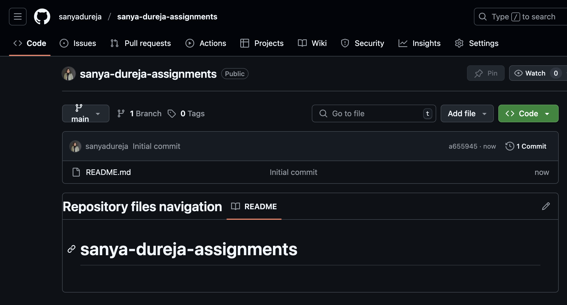

**Q7.** Create a branch called feature-java(you can use it later to push all your Java-related tasks to this branch)

**Ans 7.**

Use the command given below:

**git branch feature-java**

This will create a separate branch for Java tasks without affecting the main branch.

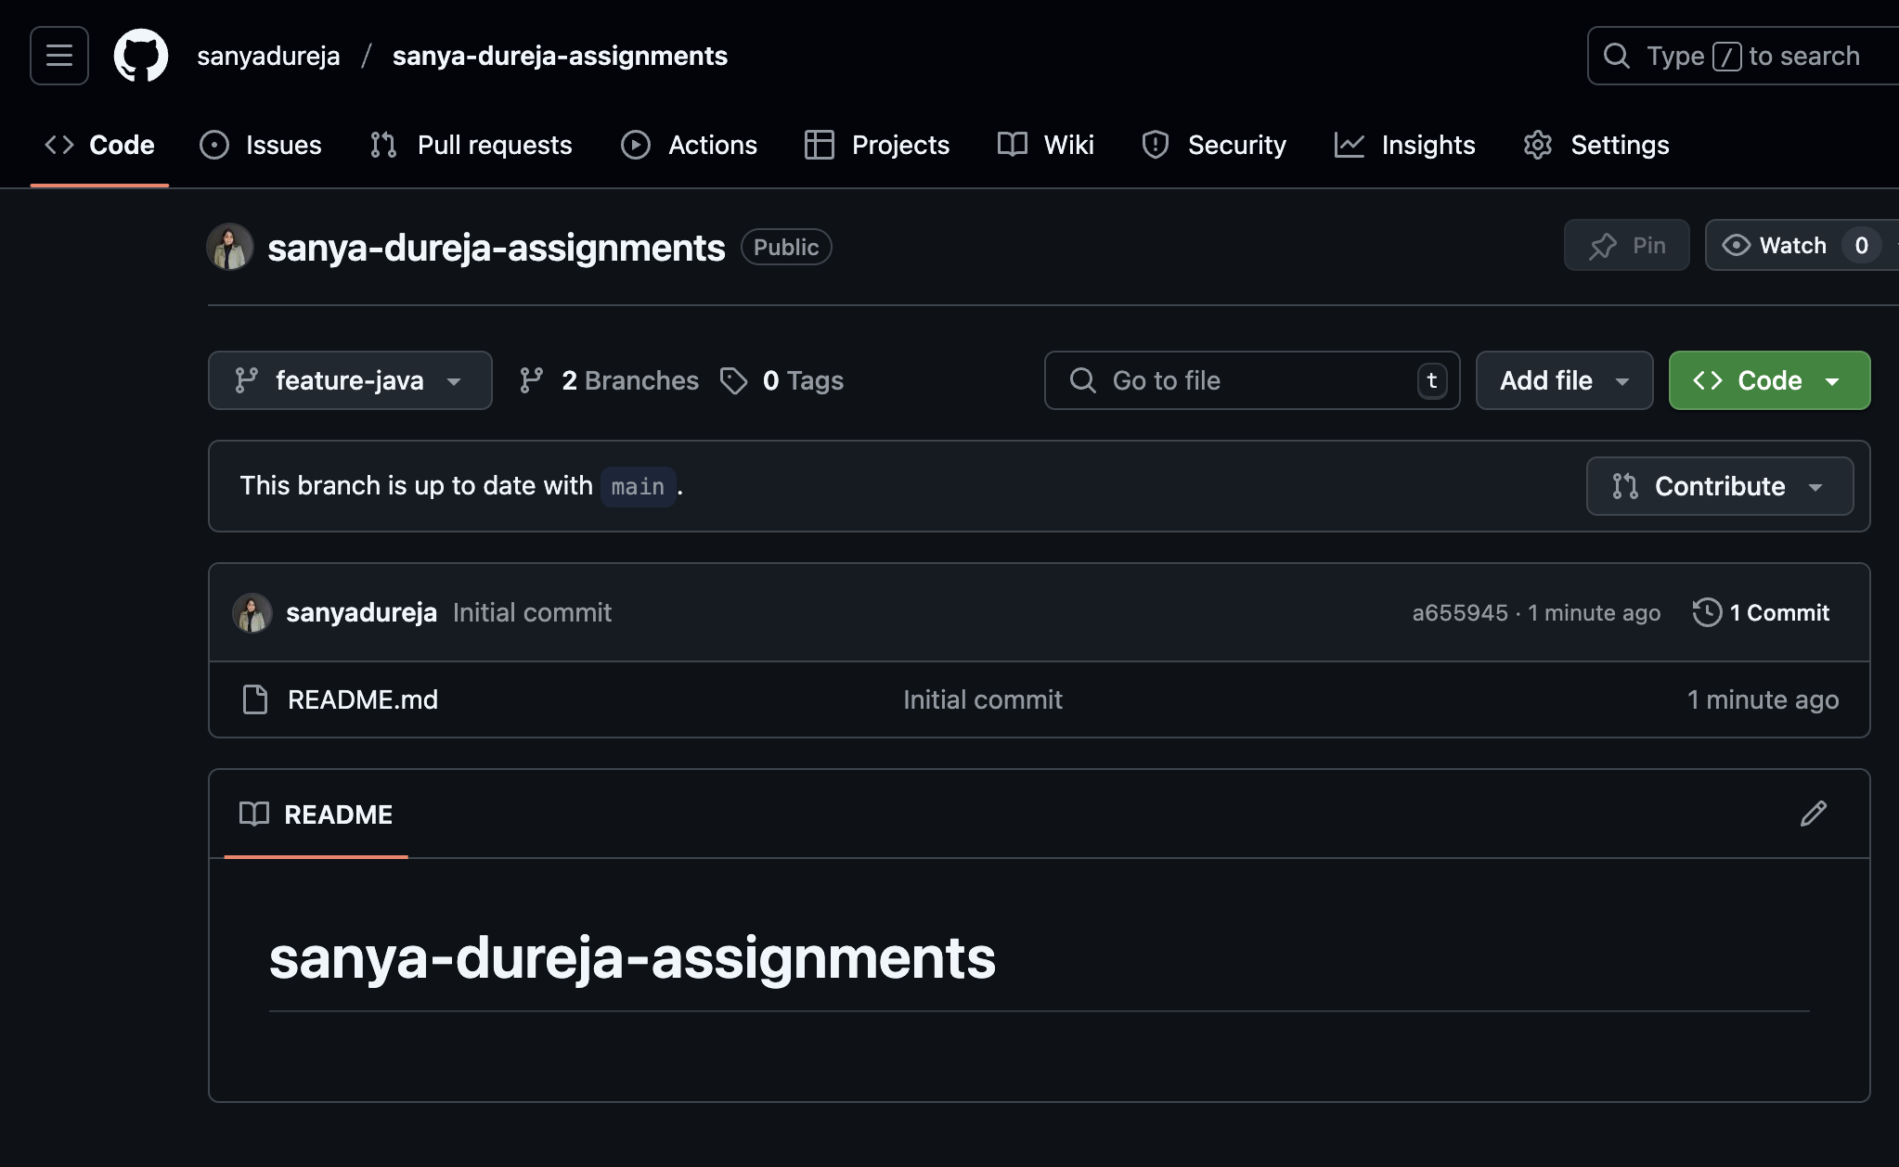

**Q8.** Install IntelliJ IDE. Create a simple Java project displaying “Hello World!!” and share the screenshot.

**Ans 8.**

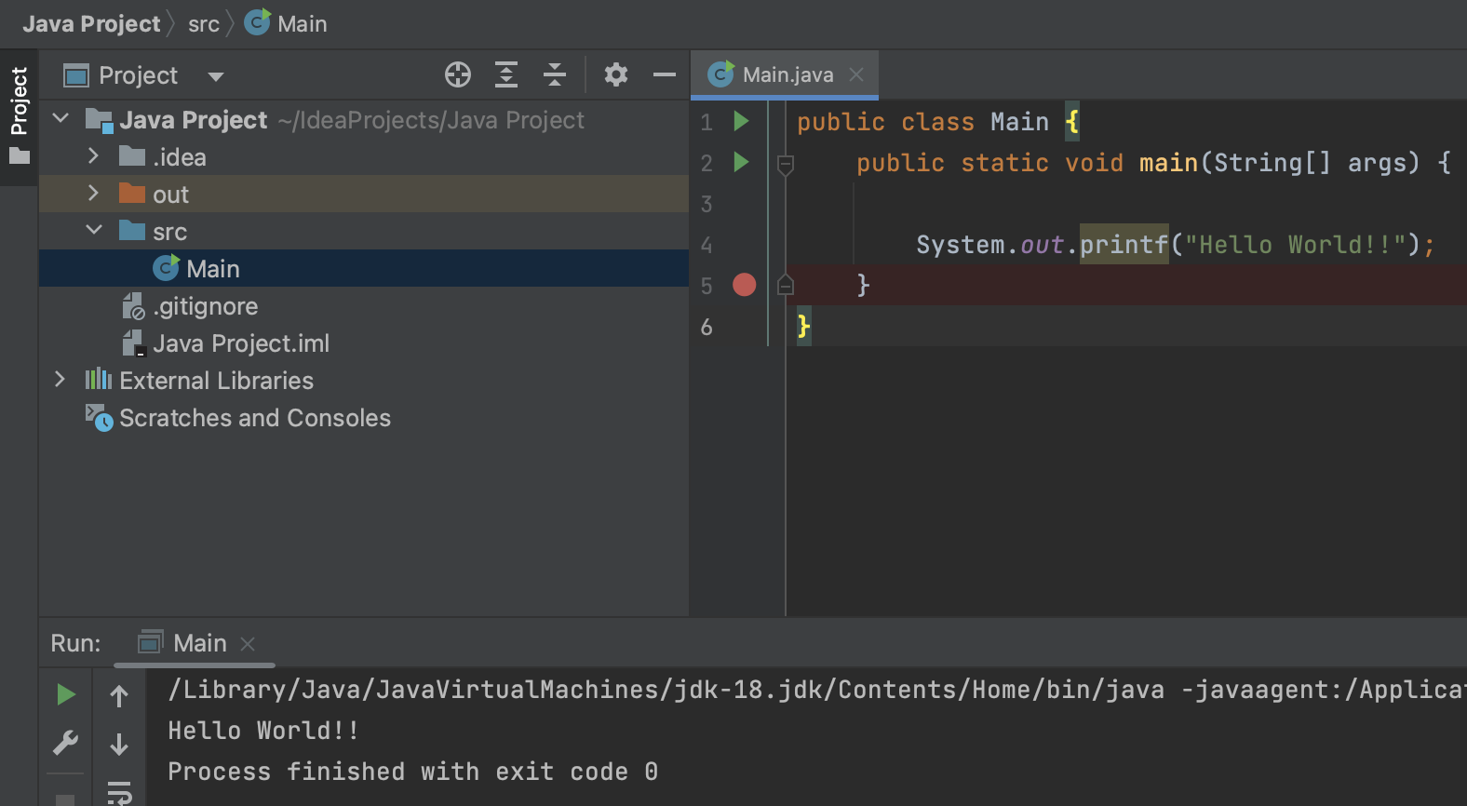

**Q9.** IntelliJ IDE, explore the shortcut keys for the following

* To run the project
* To select a line
* To comment/uncomment a line
* To delete a line

**Ans 9.**

* To run the project – **Shift + F10**
* To select a line – Home → **Shift + End or Shift + Right/Left Arrow**
* To comment/uncomment a line – **Ctrl + / (Windows/Linux) or Cmd + / (Mac)**
* To delete a line – Ctrl + Y **(Windows/Linux) or Cmd + Backspace (Mac)**